**Practical 2**

**Aim:** To demonstrate concept of Version Control Systems. To create a GIT Repository and execute different git commands.

**Procedure:**

1. Download Git <https://git-scm.com/download/win> and launch.
2. Create a repository at <https://github.com/apurvago/githome> **‘githome’**. Also create the same name folder at local disk inside Git folder.
3. Now, in VS code (Run as administrator):
   1. File🡪Open folder in workspace🡪Open **‘githome’** folder.
   2. Open in integrated terminal.

**Code:**

**PS C:\Program Files\Git\githome>**

**git init**

**git config --global user.name "apurvago"**

**git config --global user.email "gosaviapurva@yahoo.in"**

**git status**

**git add apurvagit1**

**git status**

**git commit -m "first commit"**

**git branch -M main**

**git branch**

**git status**

**git remote add origin https://github.com/apurvago/githome.git**

**git remote -v**

**git push -u origin main**

**git branch b1**

**git status**

**git checkout b1**

**git status**

* **Merge conflict:**

**Step 1:** Clone the repository or update your local repository with the latest changes.

git pull origin main

**Step 2:** Switch to the head branch of the pull request.

git checkout b1

**Step 3:** Merge the base branch into the head branch.

git merge main

**Step 4:** Fix the conflicts and commit the result.

**Step 5:** Push the changes.

git push -u origin b1

**Output:**

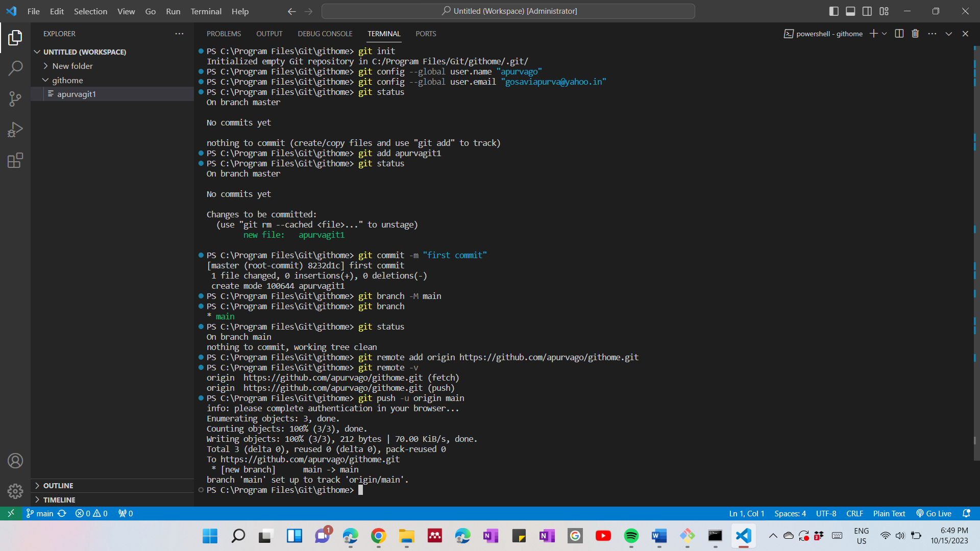

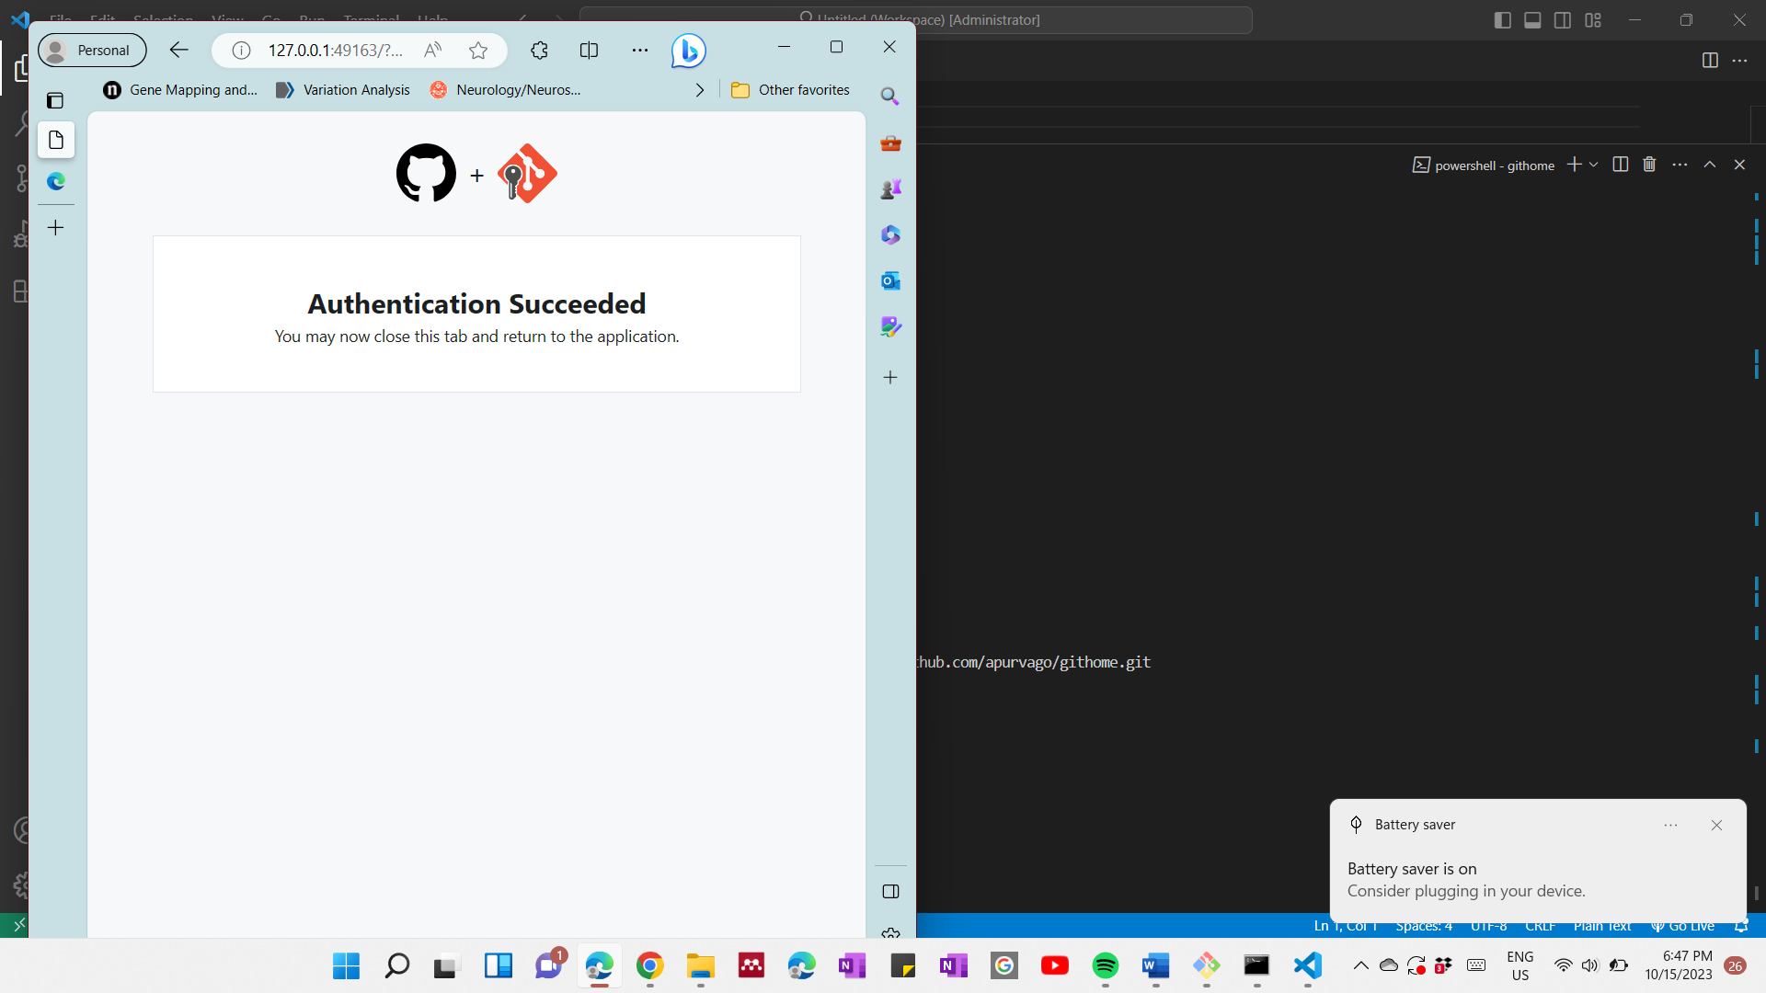

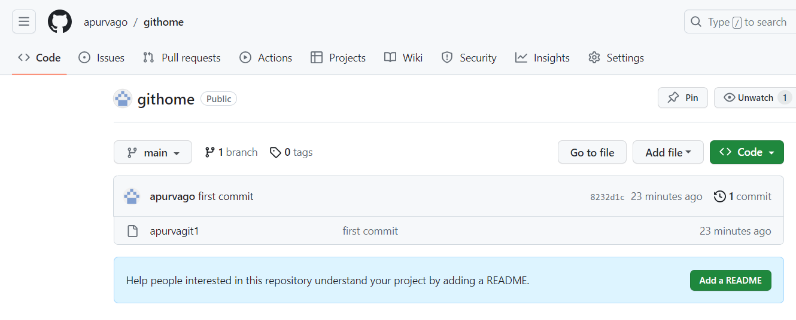

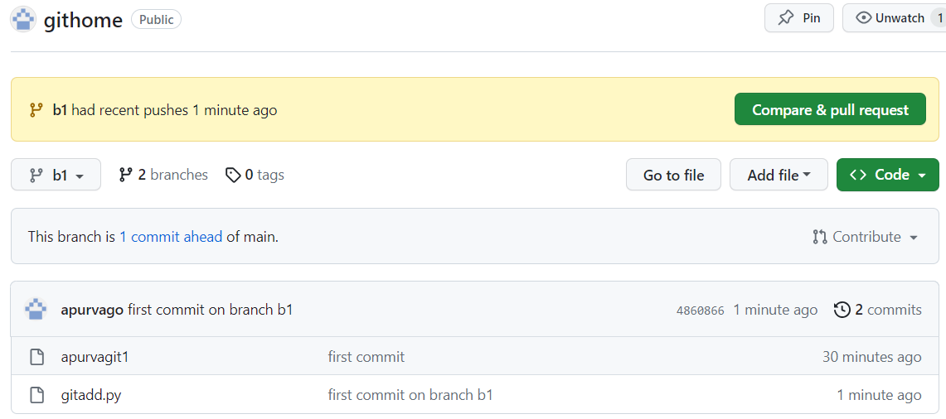

Merge conflict output:



